Zhan Yu zyu293@wisc.edu

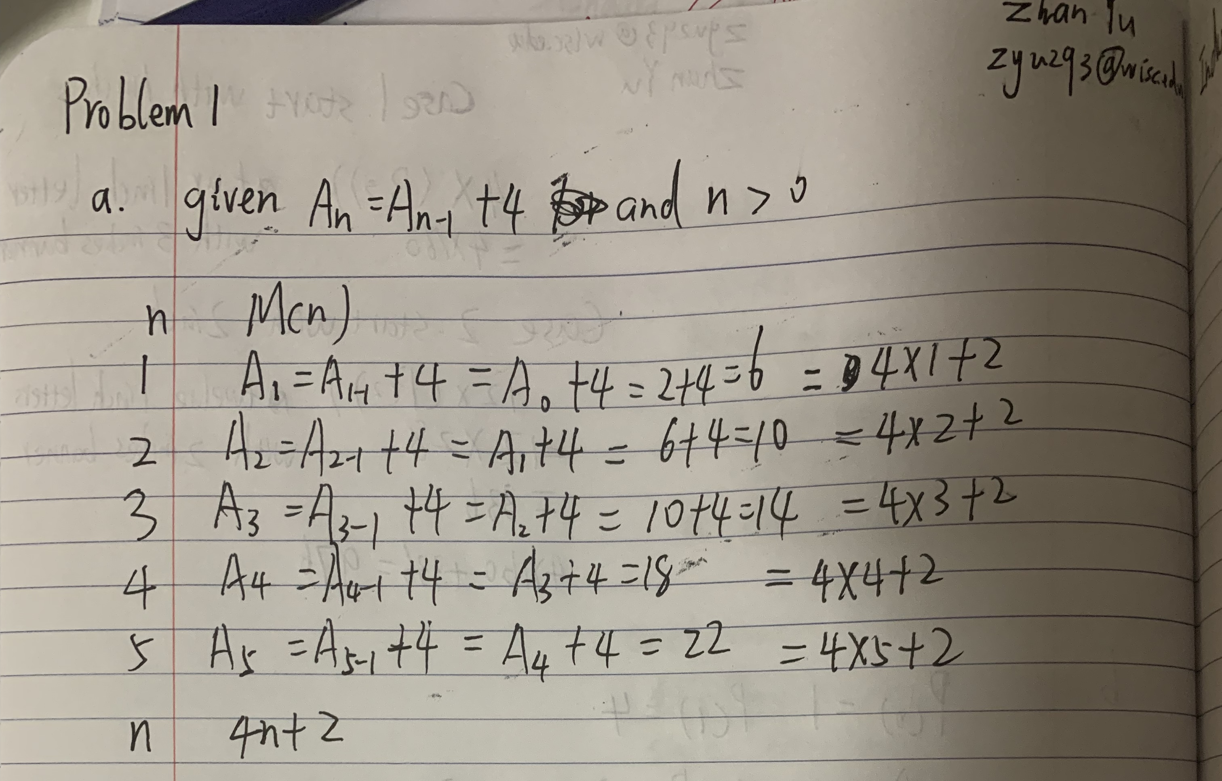

Zhan Yu zyu293@wisc.edu

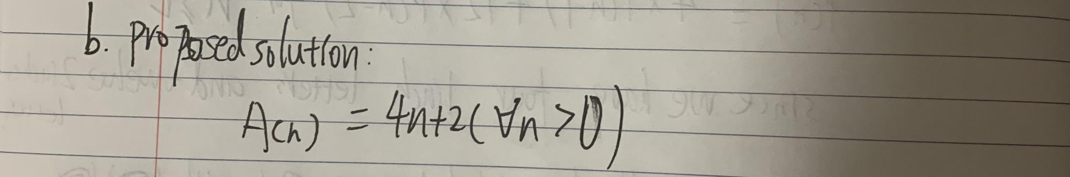

Zhan Yu zyu293@wisc.edu

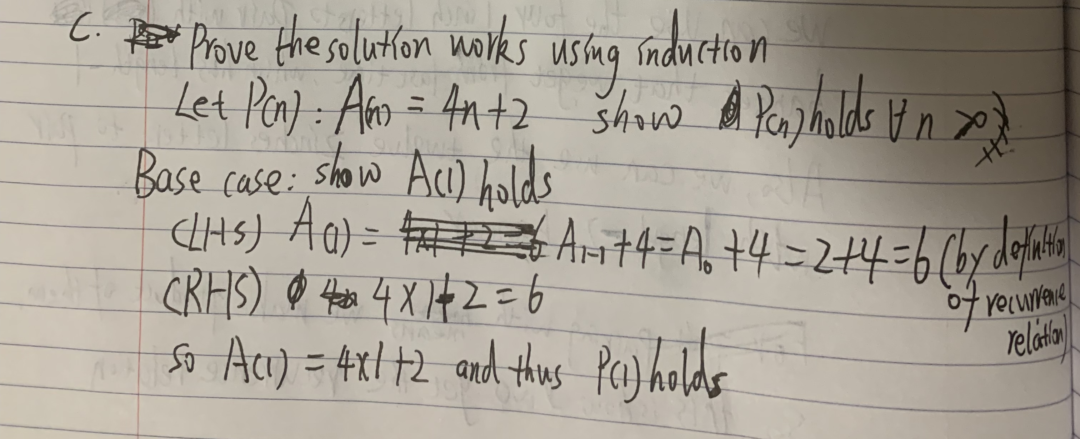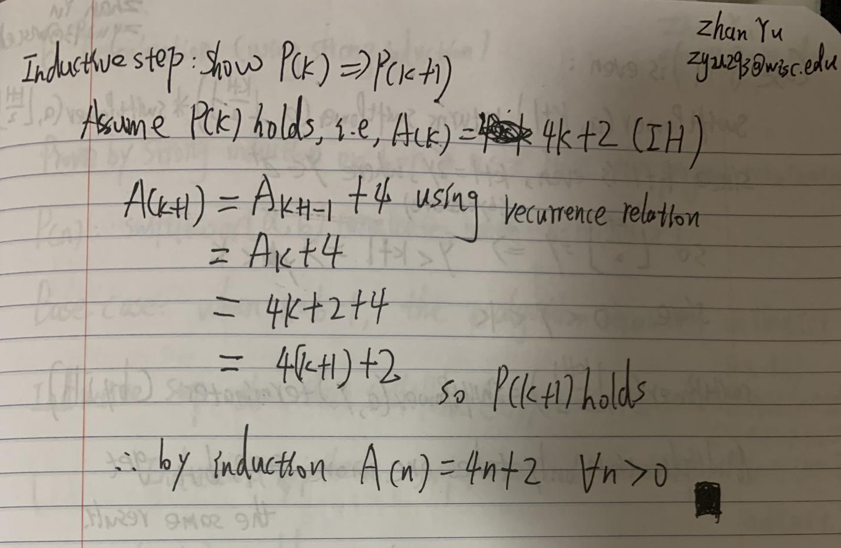

Zhan Yu zyu293@wisc.edu

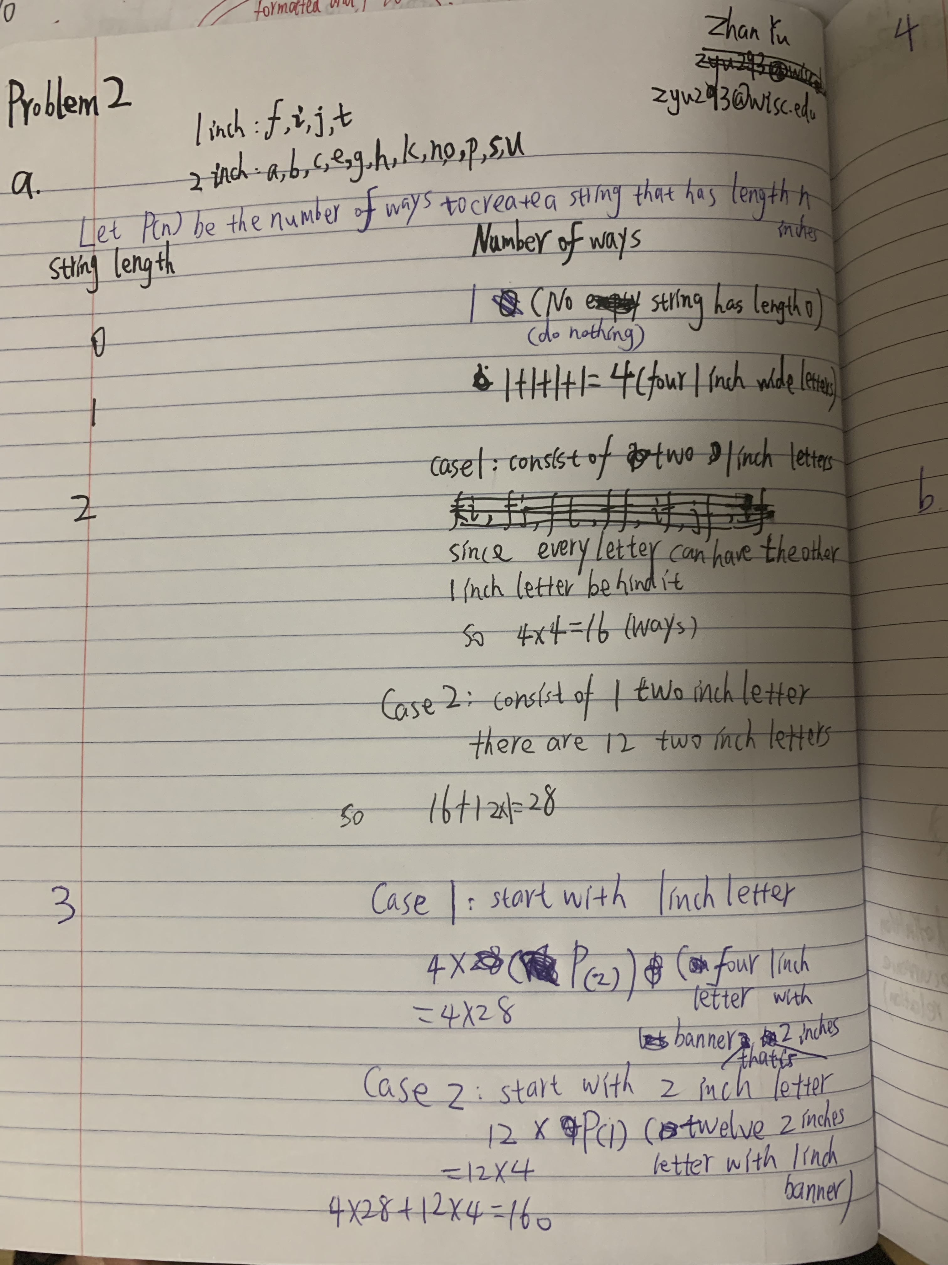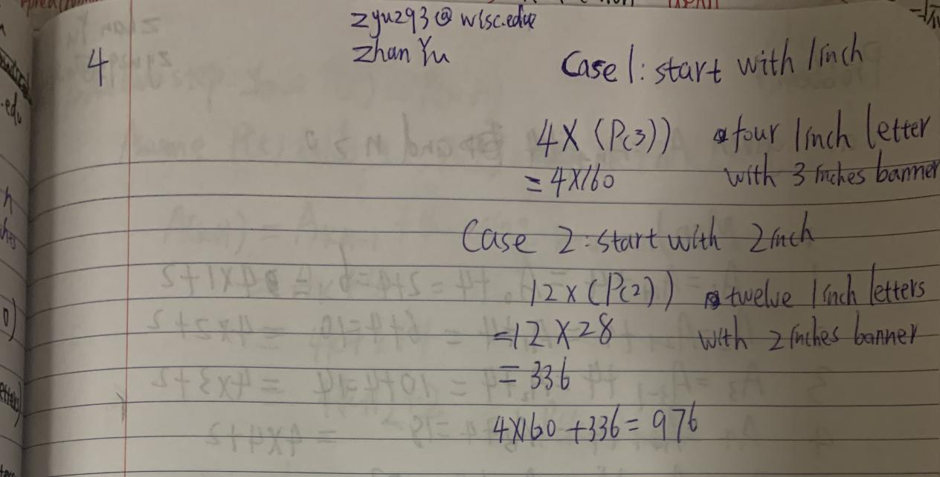

Zhan Yu zyu293@wisc.edu

